1.

Chris Ogle(高富帅), Seed Zeng(变态, 操你妈的屄)

2.





None of the attributes in either the Linux Version of main or the Windows version of _tmain were global.

All of these variables are part of the main function’s scope. They are passed into it so thus these are included in the scope.

Between the two main functions the argc, int attribute, is the same for both. However, the difference lies between the _TCHAR and the _char. The _TCHAR allows for a large encoding of characters that are not contained within the ASCII eight bit character encoding. Such as Chinese characters.

3.

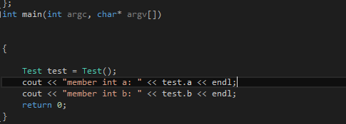

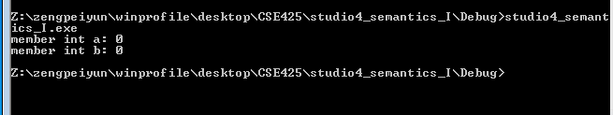

With the struct the member variables by default are public and the struct is public too. Thus we were able to access all the variables from within main.

When we converted it to a class we were unable to access the values. This is because the class member’s by default are made private.

4.

code

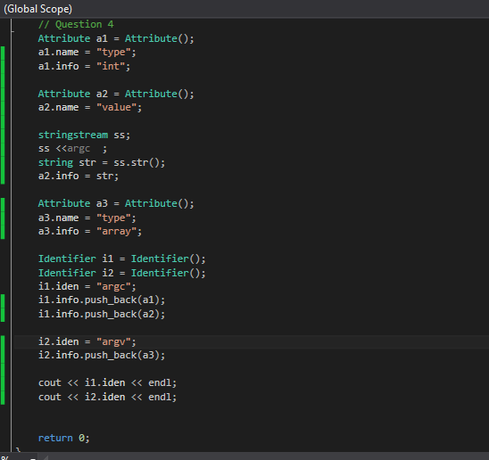

output



5.

